Yel Lin ID 6520242
Assignment 6: Gradient Descent for Linear Regression
Question 1: Linear Regression Model ug Maximum Likelihood Estimation

Step 1.1 : Plotting Training and Testing Data
- Ploting the relationship between the training data and testing data on the same graph
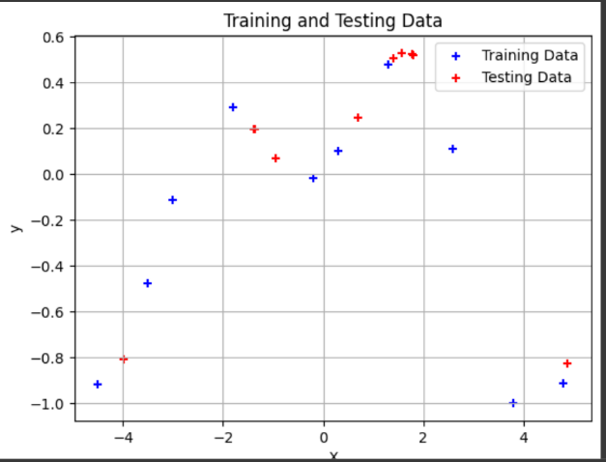


1.2 Polynomial Feature Transformation
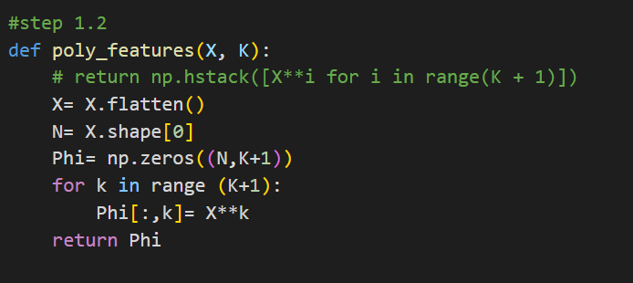
The purpose and the effect of this transformation:
Polynomial transformation enables linear models to fit nonlinear data by adding higher-degree features. It improves flexibility but risks underfitting with low degrees or overfitting with high degrees. The right degree balances accuracy and complexity for better generalization.

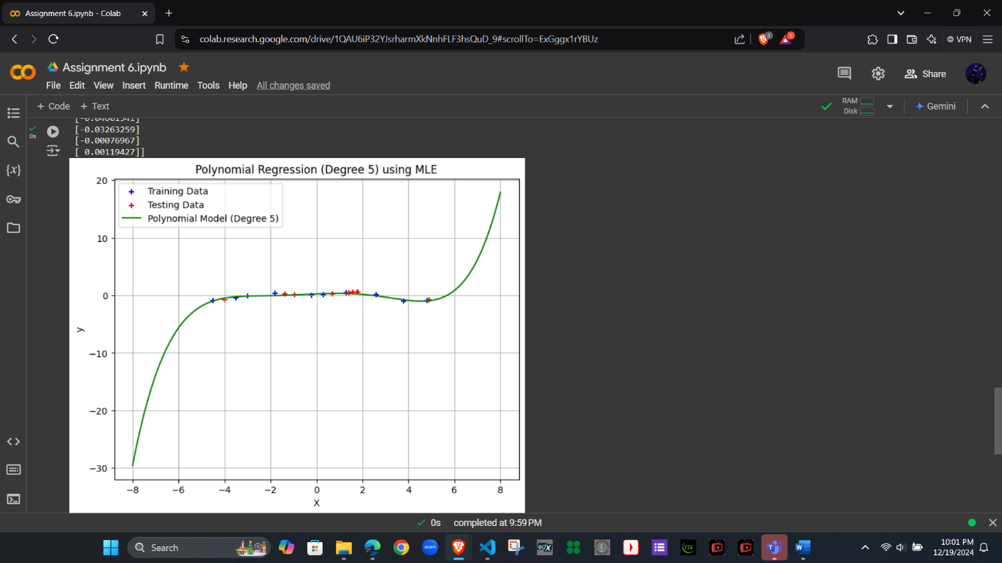
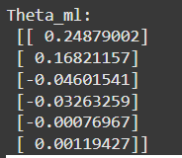
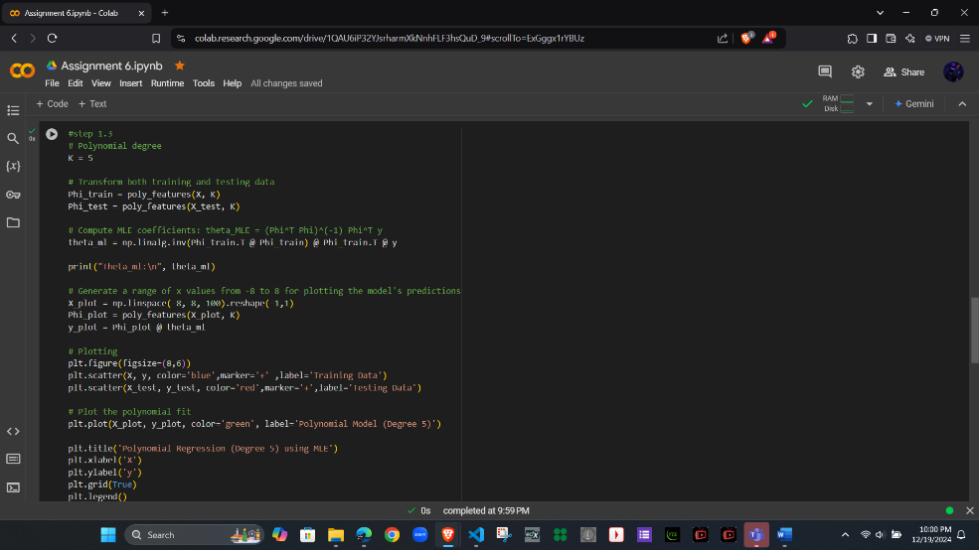
1.3 Fitting the Model Ug Maximum Likelihood

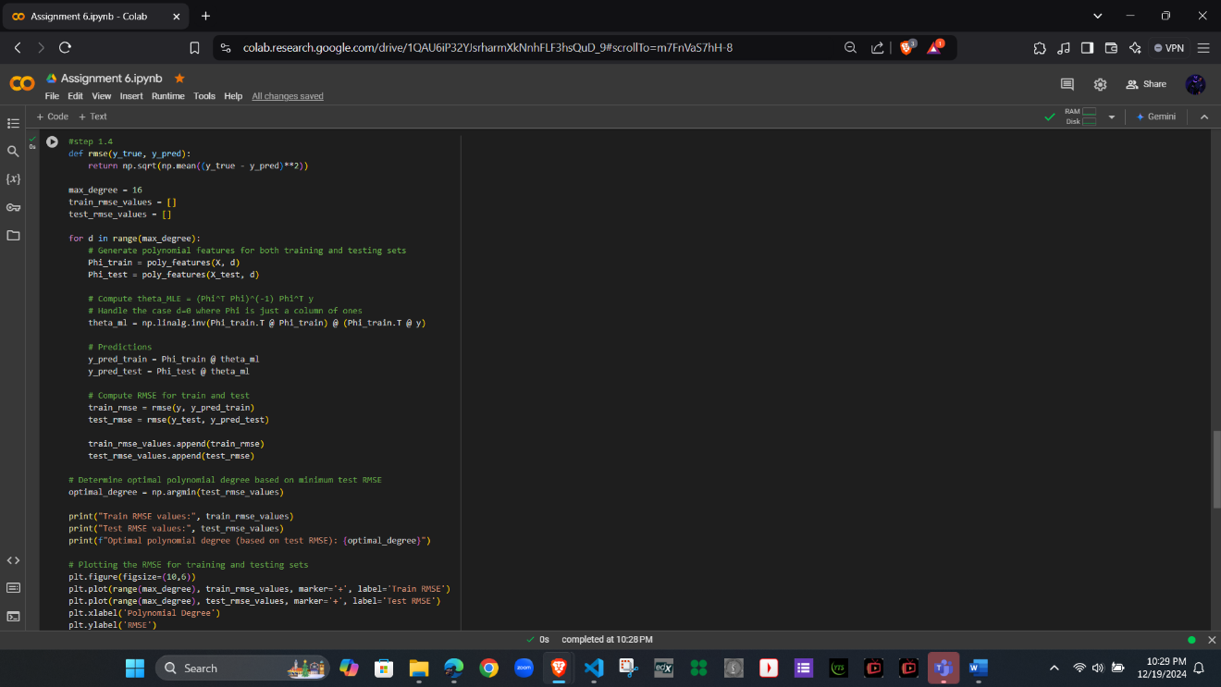
1.4 Model Evaluation

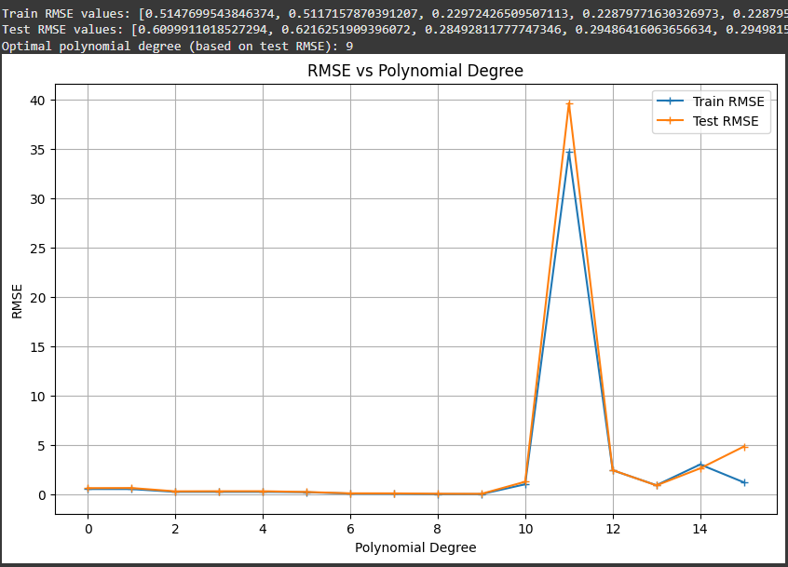

Train RMSE values: [0.5147699543846374, 0.5117157870391207, 0.22972426509507113, 0.22879771630326973, 0.22879573735413525, 0.19502327062655744, 0.05342435077718177, 0.03818517735253735, 0.003910516742283594, 5.538327228678245e-10, 0.999183995488885, 34.68901085509442, 2.4195160890609984, 0.9029673413927789, 3.0081770554024114, 1.1934142035010373]
Final Train RMSE values: 1.1934142035010373
Test RMSE values: [0.6099911018527294, 0.6216251909396072, 0.28492811777747346, 0.29486416063656634, 0.29498152071402095, 0.21742862799598514, 0.08213402882291138, 0.07763539925156139, 0.03924484661505437, 0.030724661923518273, 1.2579162752970154, 39.66507331006011, 2.435318758318806, 0.8844692052280537, 2.61375681037945, 4.830158928594374]
Final Test RMSE values: 4.830158928594374
Optimal polynomial degree (based on test RMSE): 9

1.5 Selecting the Best Model
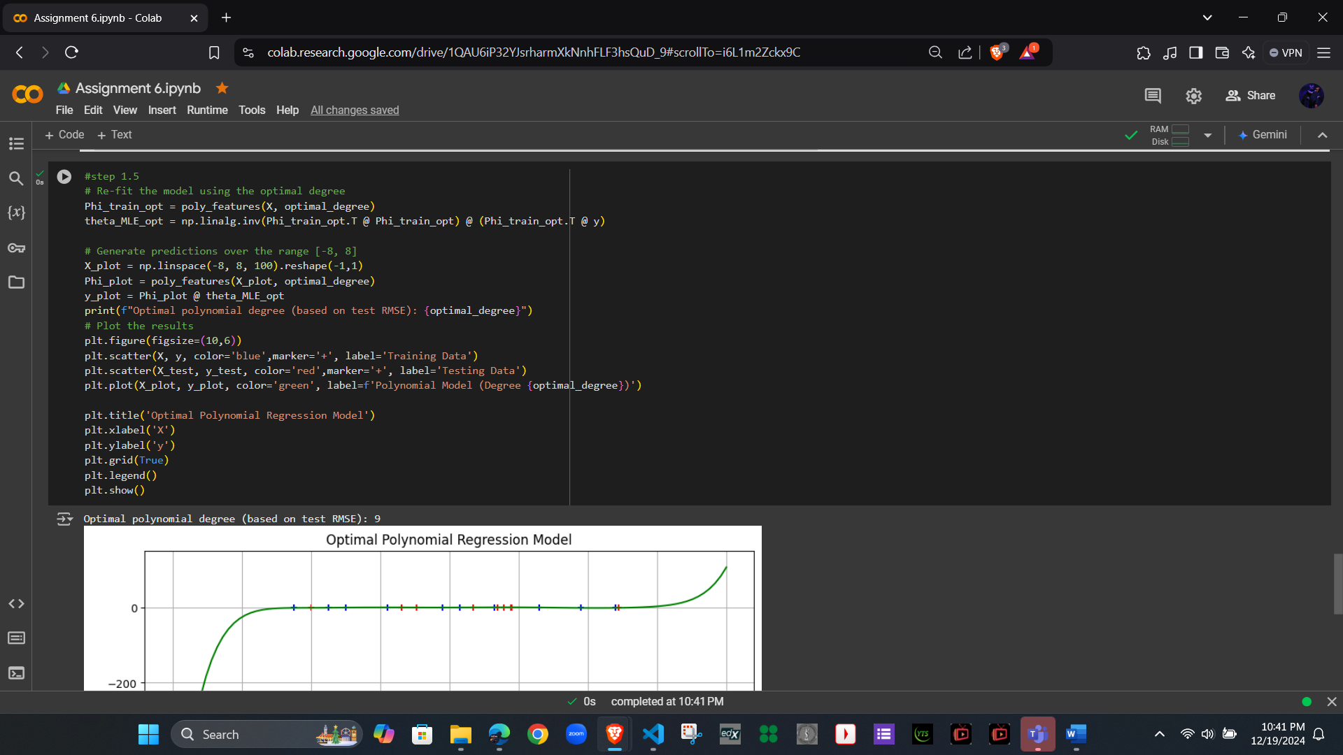
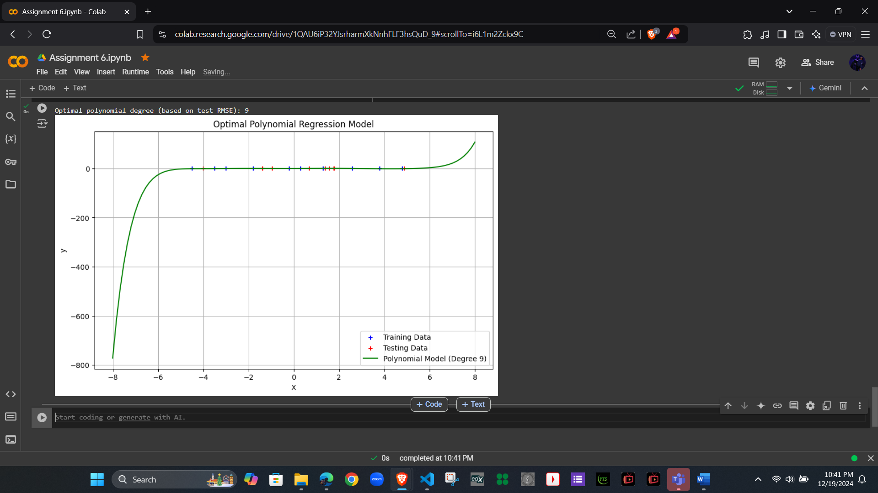
Optimal polynomial degree (based on test RMSE): 9

Question 2: Gradient Descent for Polynomial Regression
2.1 Mathematical Derivation
J(θ)=(y−ΦTθ)2
Step 1: Introduce a temporary variable
h=ΦTθ
J(θ)=(y−h)2
Step 2: Differentiate with respect to h
dJ/dh ​=2(y−h)(−1)=−2(y−h)=2(h−y)
Step 3: Differentiate h with respect to θ
h=ΦTθ=i∑​ϕi​θi​
∂h/∂θ ​=Φ
Step 4: Apply the chain rule
∇θ​J(θ)= dJ/dh​⋅∂h/∂θ ​
dJ/dh​=2(h−y)
∂h/∂θ ​=Φ
Thus , ∇θ​J(θ)=2(h−y)Φ
Step 5: Substitute h=ΦTθ
∇θ​J(θ)=2(ΦTθ−y)Φ
Final answer: ∇θ​J(θ)=2(ΦTθ−y)Φ

2.2 Feature Transformation and Gradient Descent Implementation
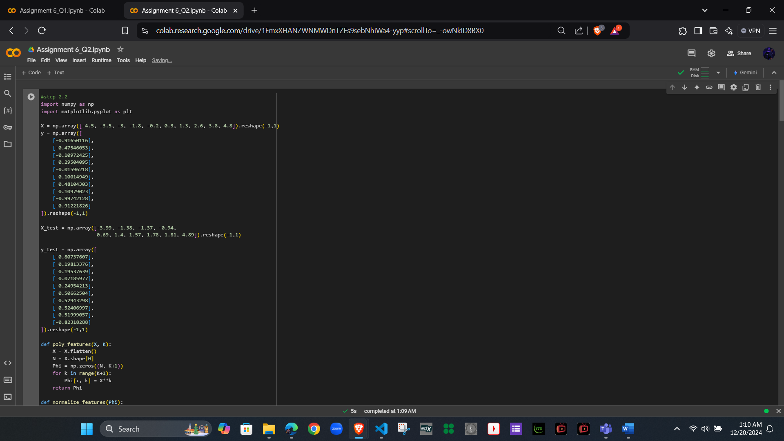
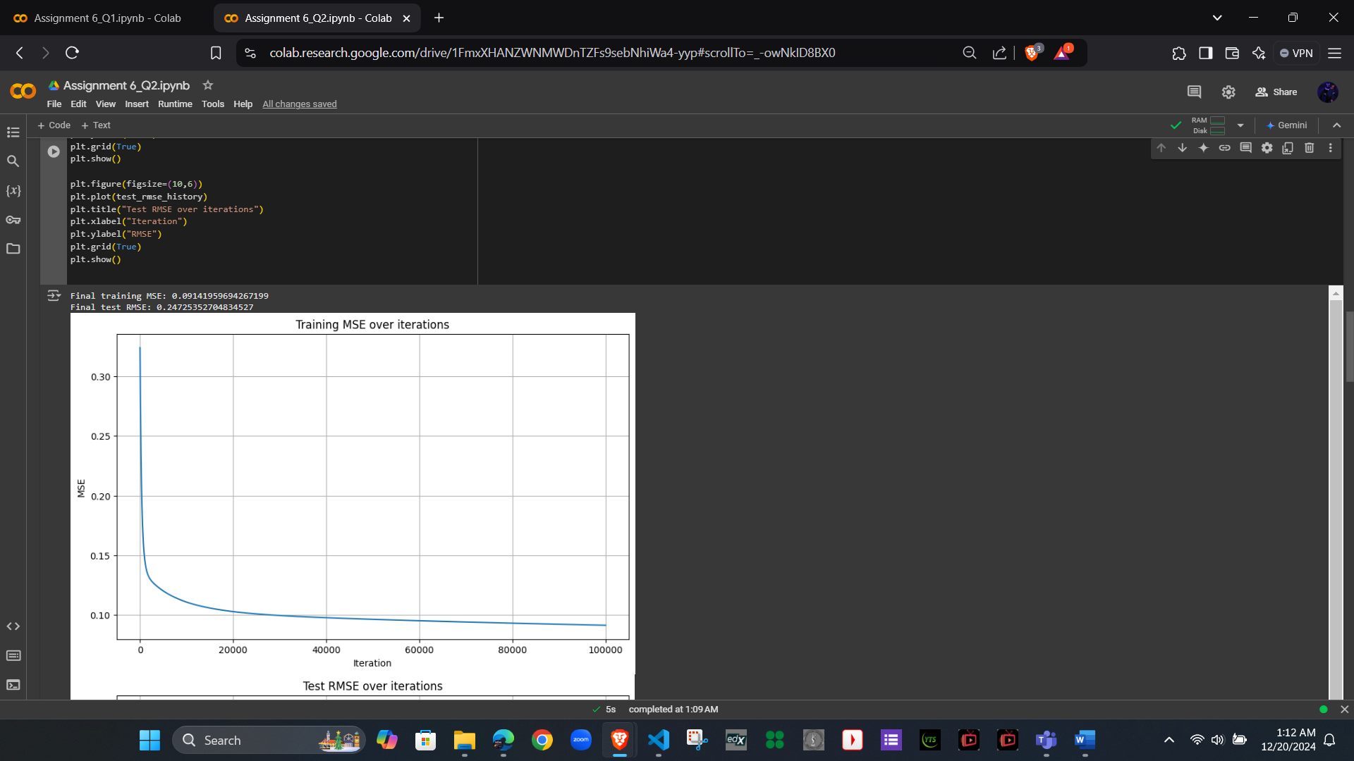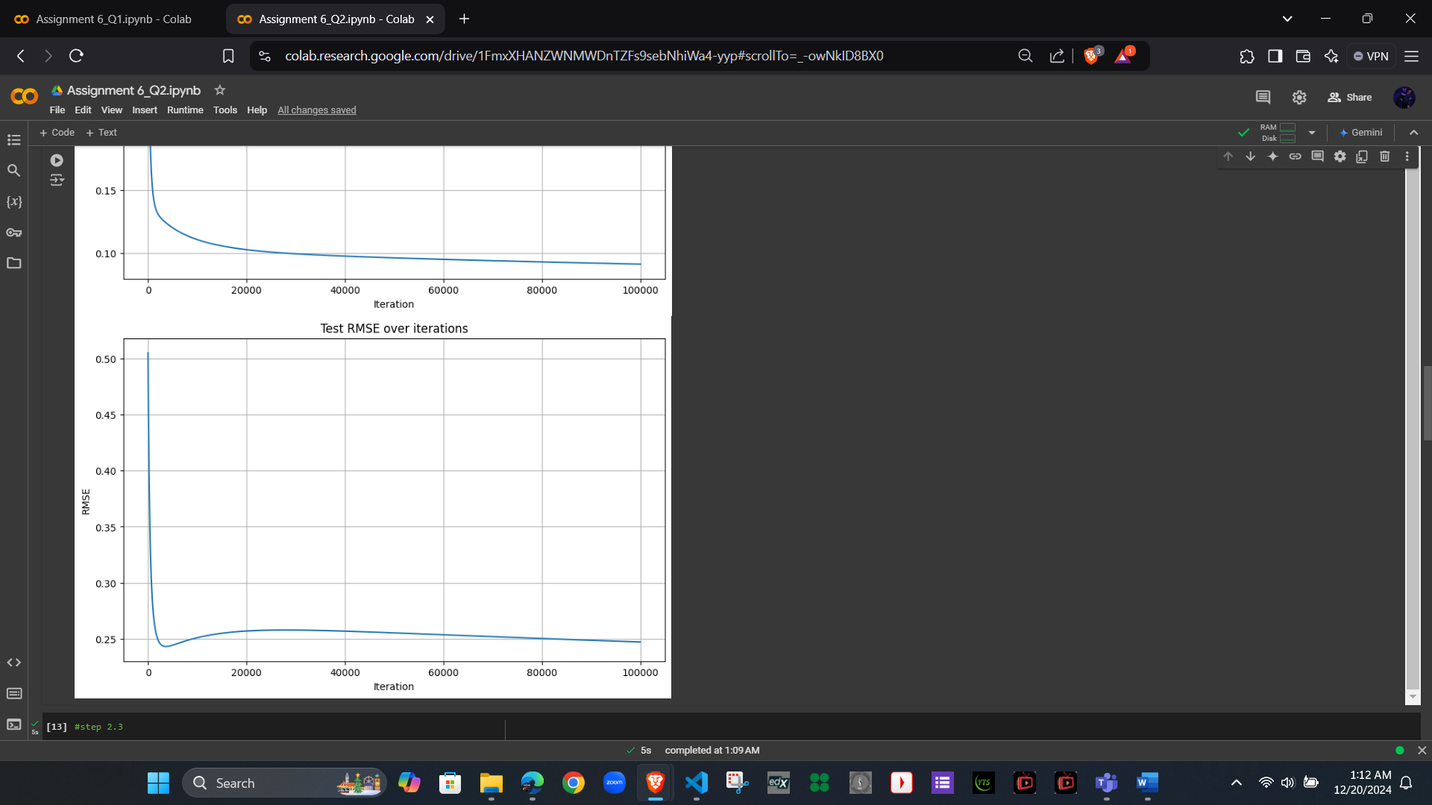

2.3 Model Evaluation and Comparison
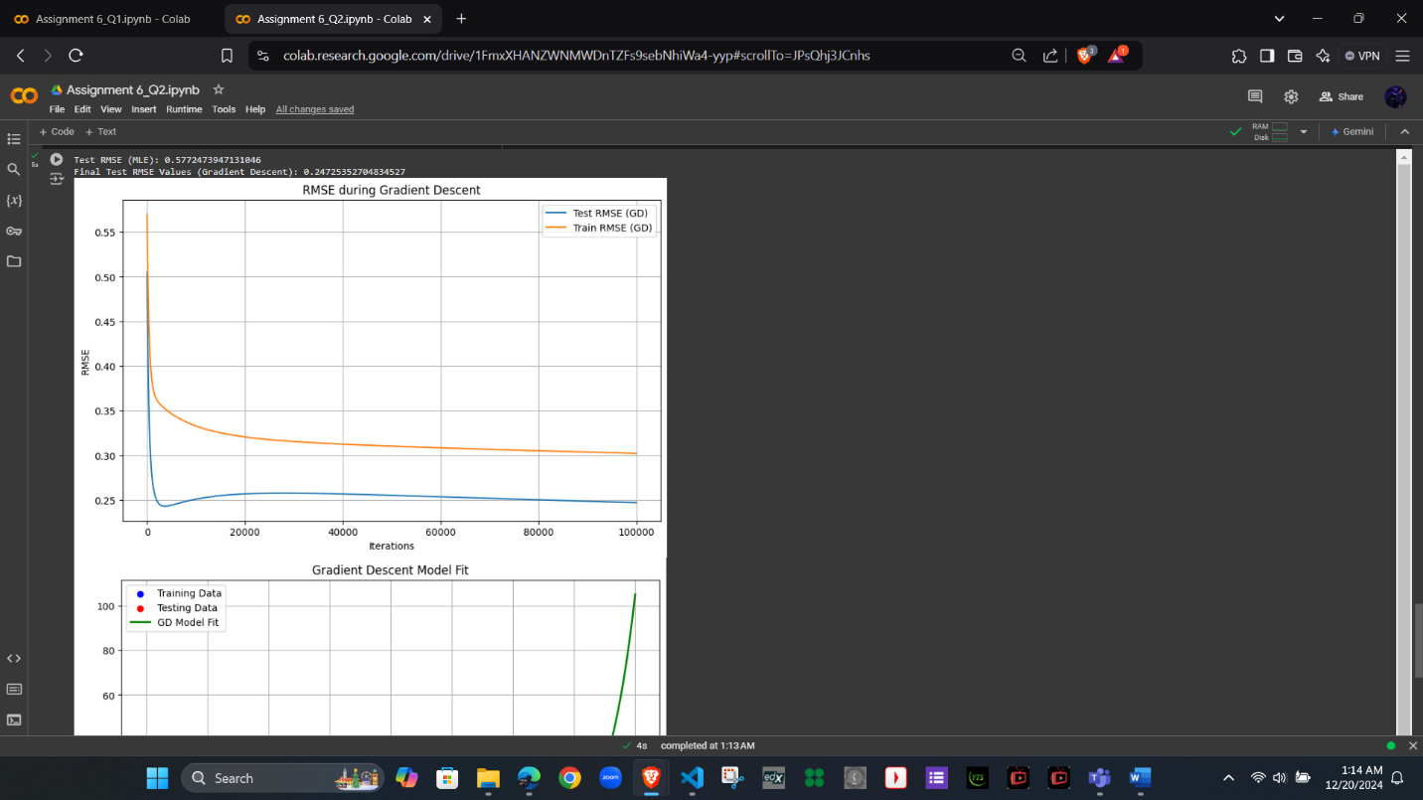
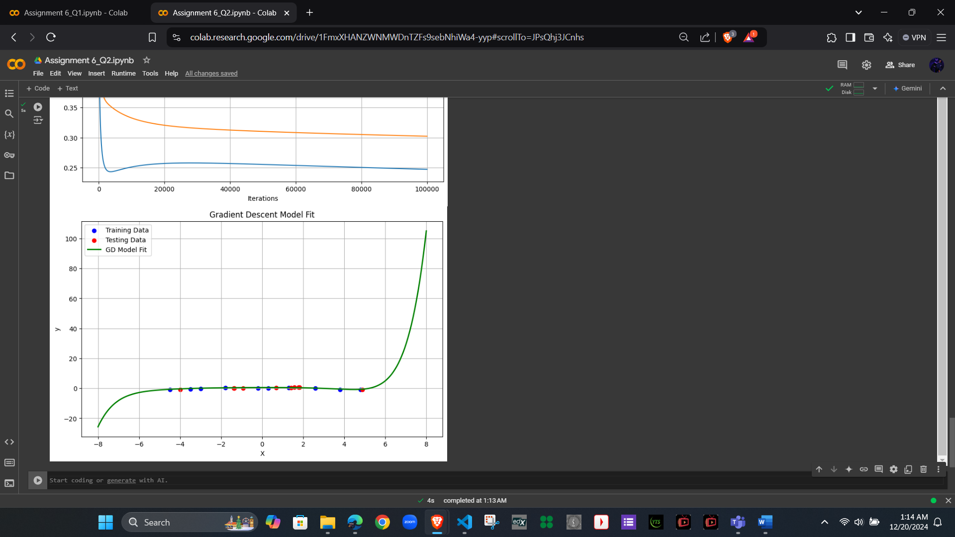
Test RMSE (MLE): 0.5772473947131046
Final Test RMSE Values (Gradient Descent): 0.24725352704834527
Discussion:
- The training MSE curve should decrease over iterations, indicating successful convergence.
- The final GD solution should produce a test RMSE similar to the MLE solution.
- Gradient Descent convergence speed and final accuracy depend on the learning rate and normalization.
- Normalization and a sufficiently small learning rate (0.0002) help ensure smooth convergence.

